1. (a)

From this scatter plot, I choose the line $x_{i2} -0.5=0$ to separate the two classes, so the intercept b = 0.5 , $ω_{1}=0, ω_{2}=1$.

(b) $γ= 0.5$

(c) $\left\|ω\right\|$ = 1

$m=\frac{γ}{\left\|ω\right\|}=$ 0.5

(d)(2,1) and (0,0) are on the margin

2.

(a) 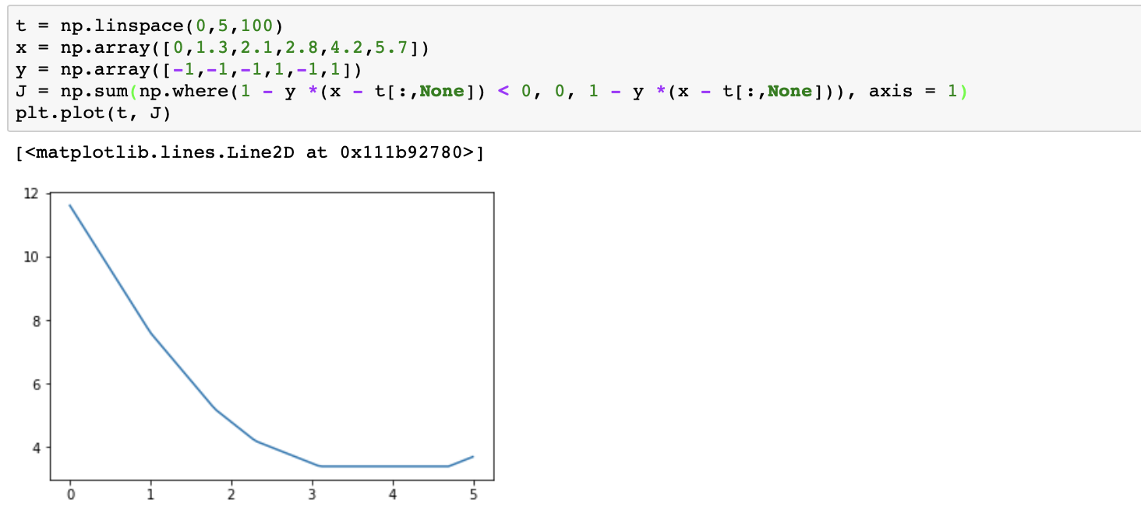

(b) 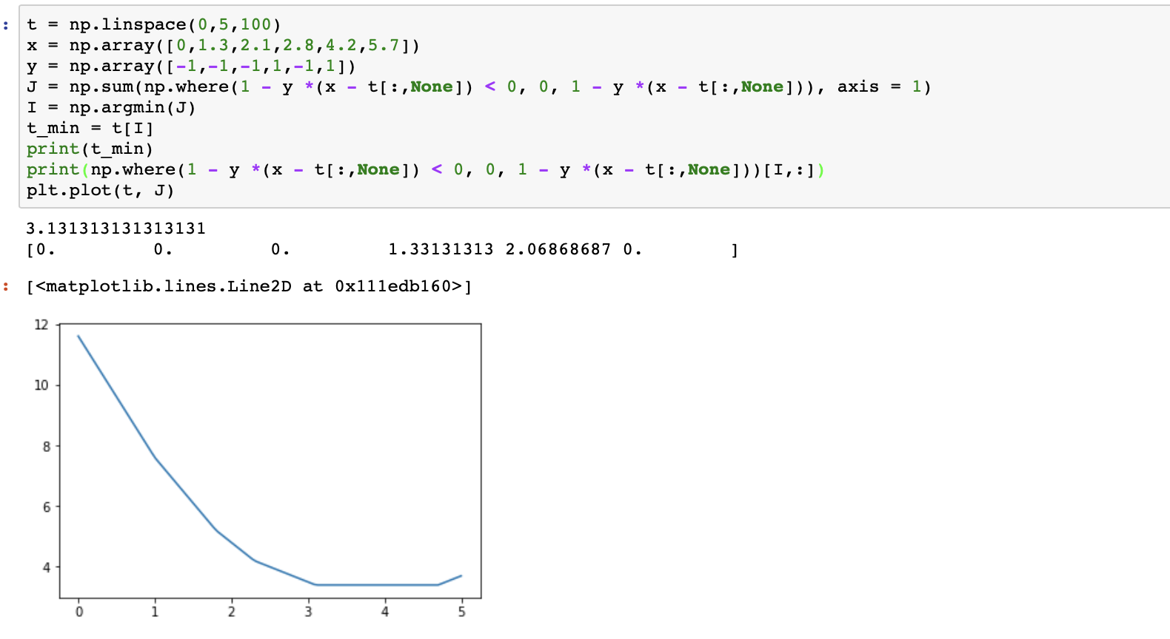

t = 3.131313

(c)



$ϵ_{i}=[ 0 0 0 1.33131313 2.06868687 0]$

(d)

sample (2.8, 1) (4.2, -1) is violate the margin , these two samples are also misclassified.

3.

(a) x = [0 0 0 0 0 0 0 0 0 1 1 1 0 0 0 0]

w = [0 0 0 0 0 1 1 0 0 1 1 0 0 0 0 0]

(b) z = 2

(c) x_right = [0 0 0 0 0 0 0 0 0 0 0 0 0 1 1 1]

z = 0

(d) x_left =[0 0 0 0 0 1 1 1 0 0 0 0 0 0 0 0]

z = 2

(e) x = Xmat.ravel()

Xmat = x.reshape((4,4))

4.

(1) 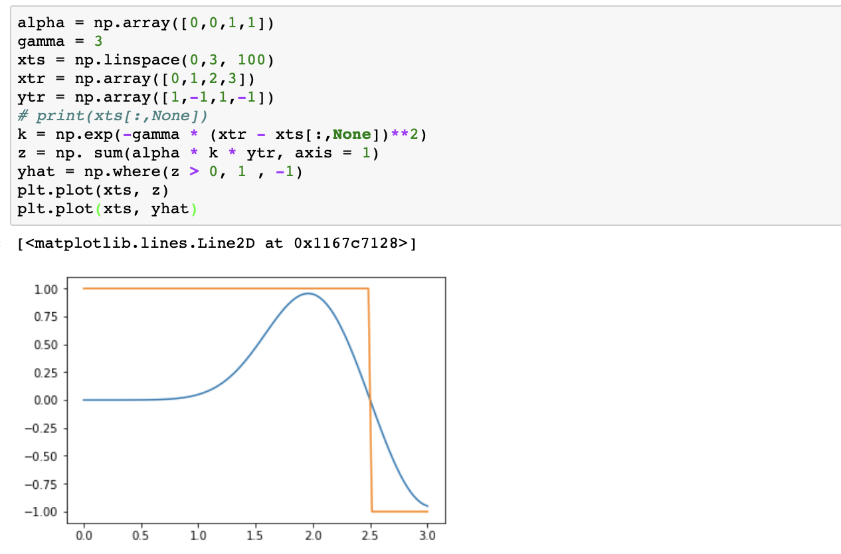

(b)

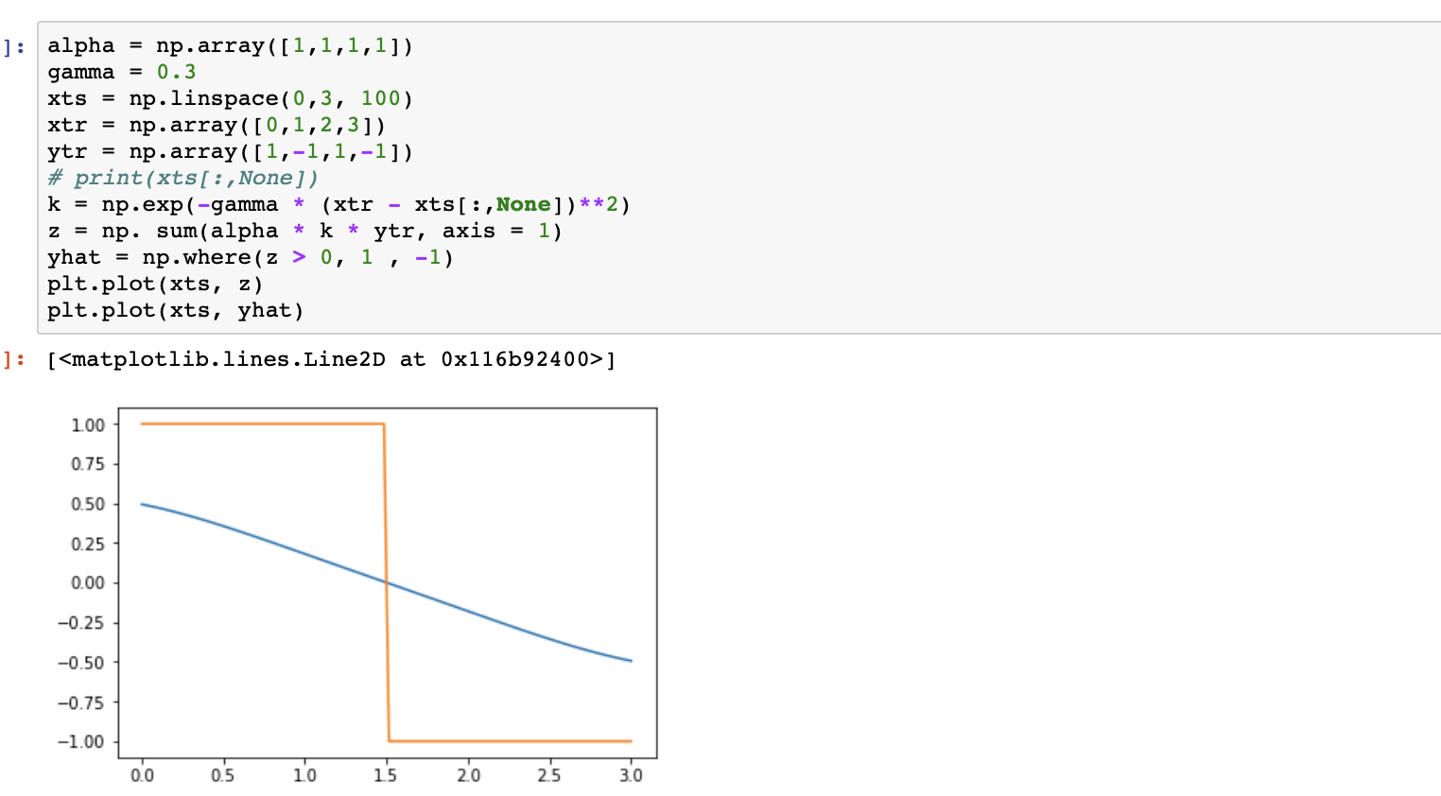

(c)

The second classifier makes more errors.